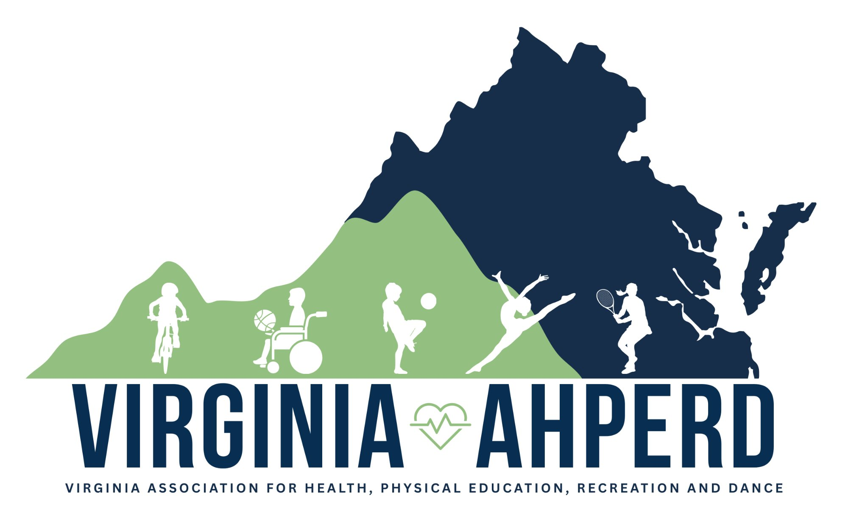 | 89TH ANNUAL CONVENTION | SPONSORSHIP OPPORTUNITIES  Convention Sponsorship Guide  October 24–25, 2026 | E.C. Glass High School, Lynchburg, VA

Currently sponsored by: Skatetime | OPEN & US Games | USTA | HealthSmart

Opportunity | What Your Sponsor Recognition Includes | Investment | Availability
Convention Events
Awards Banquet* | Named presenting sponsor of the awards reception with hot hors d'oeuvres. Verbal recognition and signage at event. | $750 | 0 / 1 filled
Lunch* | Named sponsor of Saturday lunch for all attendees. Signage and verbal recognition. | $750 | 0 / 1 filled
Convention Mixer* | Sponsor our Saturday night line dancing event and local venue outing. Verbal recognition and social media feature. | $500 | 0 / 1 filled
Coffee & Snack Stations* | Sponsor a refreshment station during breaks. Signage at station and program listing. | $300 | 0 / 4 filled
Attendee Experience
Welcome Bags | Exclusive welcome bag sponsor. Your logo featured on bags distributed to all 200+ attendees alongside the Virginia AHPERD logo. One sponsor only. | $500 | 0 / 1 filled
Door Prizes* | Donate a prize to be given away during convention. Recognition at drawing and in program. | Donation | Unlimited
Recognition & Awards
Award Plaques* | Underwrite the cost of plaques presented at the Awards Banquet. Verbal recognition and signage at event. | $500 | 0 / 1 filled
Digital & Print
Website Sponsor | Logo displayed on virginiaahperd.org (seen by 4,100+ quarterly visitors). Open to multiple sponsors. | $300/yr | Open
Email Blast | Featured in a dedicated email to ~1,000 Virginia AHPERD listserv members. Includes logo, message & link. | $200 | 0 / 1 filled
Program Booklet Ad  Half Page | Half-page ad featured in the official convention program, distributed digitally to all 200+ attendees and available for download at virginiaahperd.org. | $250 | 0 / 4 filled
Program Booklet Ad  Full Page | Full-page ad featured in the official convention program, distributed digitally to all 200+ attendees and available for download at virginiaahperd.org. | $400 | 0 / 2 filled

ALL SPONSORS RECEIVE

✔ Name/logo in convention program | ✔ Social media recognition

Ready to join our sponsor family?  Opportunities are first come, first served. We're happy to work with your budget — reach out to start the conversation. | Maria McKeown, Executive Director  info@virginiaahperd.org | (804) 252-5468  virginiaahperd.org

89TH ANNUAL CONVENTION | Exhibitor Details
Convention Exhibitor Guide
October 24–25, 2026 | E.C. Glass High School, Lynchburg, VA

SCHEDULE
 | Date | Time
Exhibitor Set Up | Friday, 10/23 | 4:00 PM-7:00 PM
Opening Gala | Saturday 10/24 | 8:00 AM
Exhibit Hall Hours | Saturday 10/24 | 8:00 AM-5:00 PM
Exhibit Hall Hours | Sunday 10/25 | 8:30 AM-12:00 PM
Exhibit Breakdown | Sunday 10/25 | 12:00 PM-1:00 PM
BOOTH FEES
Type | Early Bird Price Through 8/15 | After 8/15
8 X 16 Premium Booth | $625 | $675
8 X 8 | $475 | $500
Non-Profit Booth | $300 | $325
Electricity
ALL Booth rentals RECEIVE

✔ Lunch provided on Saturday | ✔ Table Sign
✔ Covered and/or skirted 6’ table(s) and one chair  (Additional chair available upon request) | ✔ Exhibitor Badges

A limited number of booths are available!  Register early at https://virginiaahperd.starchapter.com/meetinginfo.php. (A 3% processing fee will be added to your invoice if paying by credit card) | Megan Gittin, Convention Manager  ConvenMGR@gmail.com | (703) 593-6136  virginiaahperd.org

Exhibitor Agreements
Agreement to Conditions: Exhibitors and their employees agree to abide by all conditions contained herein. It is understood that the Virginia Association for Health, Physical Education, Recreation and Dance (hereafter referred to as Virginia AHPERD) shall have sole control of the exhibitor area.

Assignment of Space: Virginia AHPERD shall assign all exhibit spaces, but shall consider the location preference of individual exhibitors as much as possible. Assignments will be on a first paid basis. Your exhibit must be contained within the boundaries of the booth.

Payment: Full payment for space must accompany the registration. Make check payable to Virginia AHPERD. Payments for the space shall be made by the exhibitor and mailed directly to: Maria McKeown Virginia AHPERD Executive Director, 2931 Waxwing Circle Roanoke, VA. 24018. A 3% processing fee will be added if paying by credit card.

Cancellation by Exhibitor: Should the exhibitor be unable to occupy and use the exhibit space contracted for, they should contact Megan Gittin as soon as possible at 703-593-6136 or ConvenMGR@gmail.com. All sums paid by the exhibitor, less a $75 cancellation charge, will be refunded if cancellation is received in writing on or before close of business on September 23, 2026. No refunds will be made if the notice of cancellation is received after September 23, 2026.

Virginia AHPERD Liability: Virginia AHPERD undertakes no duty to exercise care, nor assumes any responsibility for the protection and safety of the exhibitor, his/her officials, agents or employees, or the protection of the property used in connection with the exhibit, from theft, damage or destruction by fire, accident or any other cause.

Exhibitor Liability: Exhibitor assumes entire responsibility and hereby agrees to protect, indemnify and defend Virginia AHPERD, it's employees, and agents harmless against any claims, losses and damages to persons or property caused by exhibitor's installation, removal, maintenance or use of the exhibitor's premises. Each party to this Agreement shall indemnify, defend, and hold harmless the other party and it's officers, directors, agents, and employees from and against any and all demands, claims, damages to persons or property, losses and liabilities, including reasonable attorney's fees (collectively "Claims"), arising solely out of or solely caused by the indemnifying party's negligence or willful misconduct in connection with the provision and use of convention space as contemplated by this Agreement. This paragraph shall not waive any statutory limitations of liability available to either party, including innkeepers' limitations of liability laws, nor shall it waive any defenses either party may have with respect to any Claim.

Insurance: In all cases, exhibitors wishing to insure their goods must do so at their own expense. Also, any exhibitor who wishes to make a presentation must provide proof of liability coverage and must submit a presentation form provided to them.

Registration Policies: Exhibitors are welcome to participate in educational sessions and activities taking place in the exhibit area, including refreshments and social activities.

Hotel Room Block Details
Hampton Inn:
The Hampton Inn & Suites Lynchburg-VA, located at 3600 Liberty Mountain Drive, is a top-rated, comfortable, and pet-friendly hotel adjacent to Liberty University and near Lynchburg Regional Airport. Guests enjoy free hot breakfast, an indoor pool, a fitness center, and free WiFi; making it ideal for both university visits and travelers exploring Wards Road shopping.

Springhill Suites:
The SpringHill Suites by Marriott Lynchburg Airport/University Area is a 3-star, all-suite hotel located on Wards Road, offering spacious rooms with separate living/sleeping areas, free Wi-Fi, and complimentary breakfast. Located near Liberty University and the airport, it features a 24/7 fitness center, seasonal outdoor pool, and a firepit.

Convention Block Rate for both sites: $139.00 plus tax 7.3%. Breakfast is included.

